**Types of SQL statements**  
  
SQL statements are categorized into four different type of statements, which are

1. DML (DATA MANIPULATION LANGUAGE)
2. DDL (DATA DEFINITION LANGUAGE)
3. DCL (DATA CONTROL LANGUAGE)
4. TCL (TRANSACTION CONTROL LANGUAGE)

Let's see one by one.  
  
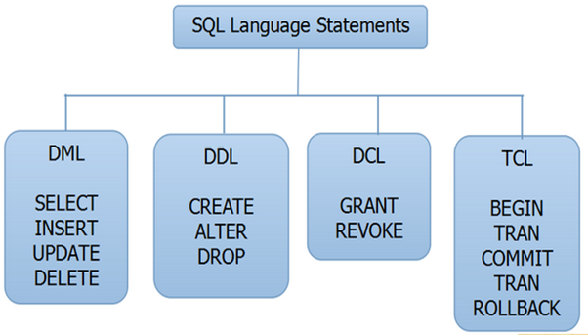  
  
**DML**  
In Data Manipulation Language(DML), we have four different SQL statements.

1. **SELECT**  
     
   Select statement is used to select the collection of records from the table, which is based on some condition.  
     
   E.g. select * from student – Get all the records of student table.  
     
   Select * from student where rank>5 – Get the records with the condition where students' rank is greater than 5.
2. **INSERT**Insert statement is used to insert the set of values into the table.  
     
   E.g. Insert into Student (Rank, StudentName, Mark) Values(1,’Kumar’,450)
3. **UPDATE**Update statement is used to update the existing values in the table, which is based on some condition.  
     
   E.g., update student set StudentName=’Manoj’ where StudentName=’Kumar’   
     
   The query given above will update the studentName from Manoj to Kumar where student Name Kumar.
4. **DELETE**Delete statement is used to delete the existing record in the table, which is based on some condition.  
     
   Eg., Delete from Student where StudentName=’Manoj’  
     
   The query given above will delete the record which has StudentName Manoj.

**DDL**  
In Data Definition Language (DDL), we have three different SQL statements.

1. **CREATE**  
     
   Create statement is used to create the new table in an existing database.  
     
   Eg., Create Table Student (Rank Int,StudentName varchar(50),Mark Float)
2. **ALTER**  
     
   Alter statement can add a column, modify a column, drop a column, rename a column or rename a table.  
     
   Eg., Alter Table Student Add (StudentAddress varchar (100))
3. **DROP**  
     
   SQL DROP TABLE statement is used to remove a table definition and all the data, indexes, triggers, constraints and permission specifications for the table.  
     
   Eg, Drop Student

DATA FILTERING /DATA FETCHING/DATA RETRIEVAL

ALL TYPES OF SELECT SQL STATEMENTS

USING

1. WHERE CONDITION

2.FUNCTIONS

3.GROUP BY AND HAVING

4.SET OPERATORS

5. DOT OPERATORS

6.CONSTRAINTS